**Program 1:**

#include <iostream>

using namespace std;

int main() {

int arr[9];

for (int i=0; i<10; i++)

{

cout<<"Enter a number : "<<endl;

cin>>arr[i];

}

for (int i=0; i<10; i++) {

cout<< arr[i] <<" ";

}

return 0;

}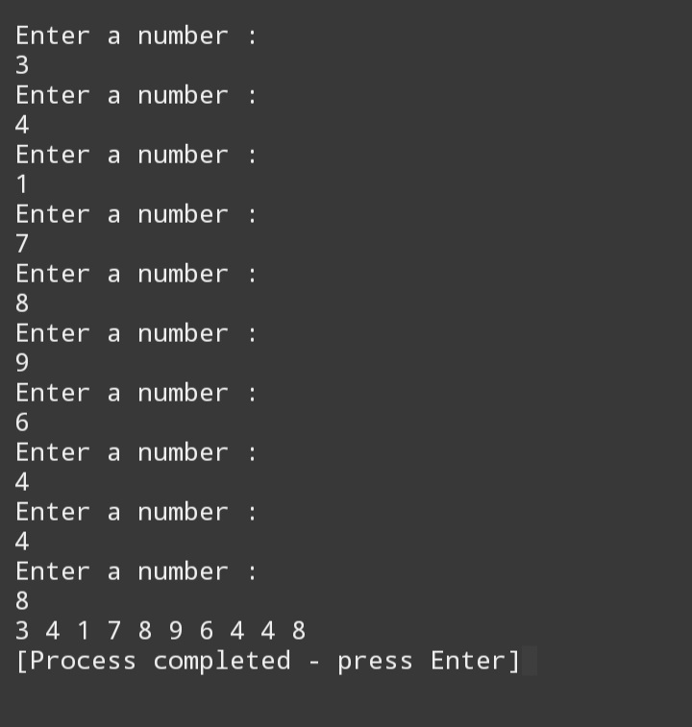

**Program 2**

#include <iostream>

using namespace std;

int main() {

int array[5];

cout << "Enter 5 integer elements:";

for (int i = 0; i < 5; ++i) {

cin>>array[i];

}

int sum=0;

int product=1;

for (int i=0;i<5;++i)

{

sum+= array[i];

product*= array[i];

}

cout << "Sum: " << sum << endl;

cout << "Product: " << product << endl;

return 0;

}

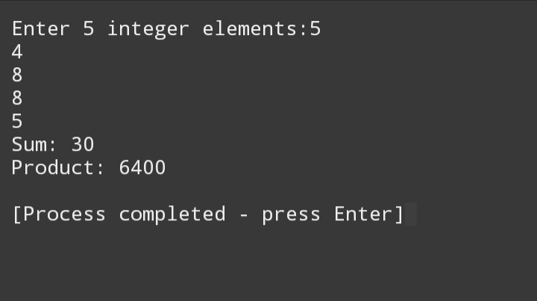

**Program 3**

#include <iostream>

using namespace std;

int main() {

int n,rows;

cout << "Enter odd numbered size of the diamond: "<<endl;

cin >> n;

rows = (n + 1) / 2;

int diamondArray[n][n];

for (int i = 0; i < n; ++i)

{

for (int j = 0; j < n; ++j)

{

diamondArray[i][j] = 0;

}

}

int num = 1;

for (int i = 0; i < rows; ++i) {

for (int j = 0; j < n; ++j) {

if (j >= rows - i - 1 && j <= rows + i - 1) {

diamondArray[i][j] = num++;

}

}

}

for (int i = rows; i < n; ++i) {

for (int j = 0; j < n; ++j) {

if (j >= i - rows + 1 && j <= n - (i - rows) - 2) {

diamondArray[i][j] = num++;

}

}

}

for (int i = 0; i < n; ++i) {

for (int j = 0; j < n; ++j) {

if (diamondArray[i][j] == 0) {

cout << " ";

} else {

cout << diamondArray[i][j] << " ";

}

}

cout << endl;

}

return 0;

}

